**Project Design Phase-II**

**Technology Stack (Architecture & Stack)**

|  |  |
| --- | --- |
| Date | 31 January 3035 |
| Team ID | SWTID1742986012 |
| Project Name | Survey Form |
| Maximum Marks | 4 Marks |

**Technical Architecture:**

The Deliverable shall include the architectural diagram as below and the information as per the table1 & table 2

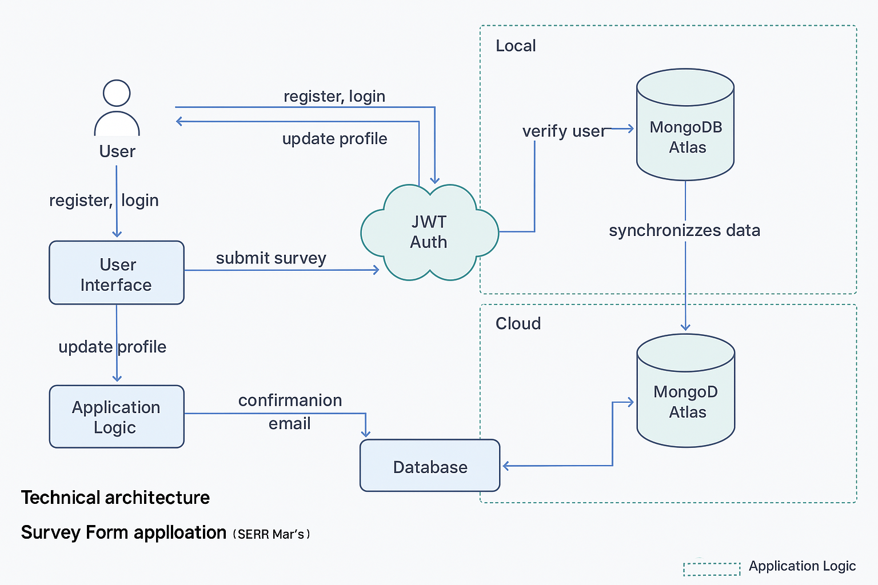

**Table-1: Components & Technologies**

| **S.No** | **Component** | **Description** | **Technology** |
| --- | --- | --- | --- |
| **1.** | **User Interface** | **Web interface for users to register, log in, fill survey, and view profile** | **React.js, HTML, CSS, JavaScript** |
| **2.** | **Application Logic-1** | **Authentication logic, JWT token generation & validation** | **Node.js, Express.js** |
| **3.** | **Application Logic-2** | **Profile update and survey submission** | **Node.js, Express.js** |
| **4.** | **Application Logic-3** | **Toast notifications and routing within React** | **React.js, React Toastify** |
| **5.** | **Database** | **Stores user data, login info, and survey responses** | **MongoDB (NoSQL), Mongoose ORM** |
| **6.** | **Cloud Database** | **Cloud-hosted MongoDB database** | **MongoDB Atlas** |
| **7.** | **File Storage** | **No file storage in this version, can be extended for survey files** | **Local filesystem / Cloudinary (optional)** |
| **8.** | **External API-1** | **Optional – for adding features like country/city lookup, email services** | **SendGrid API (for email confirmation)** |
| **9.** | **External API-2** | **Optional – Aadhaar verification for identity (future scope)** | **UIDAI Aadhaar API (Future)** |
| **10.** | **Machine Learning Model** | **Not currently used, can be used for analyzing survey sentiment** | **N/A** |
| **11.** | **Infrastructure (Server / Cloud)** | **Deployment and hosting of backend and frontend apps** | **Render (Backend), Netlify (Frontend)** |

**Table-2: Application Characteristics:**

| **S.No** | **Characteristics** | **Description** | **Technology Used** |
| --- | --- | --- | --- |
| **1.** | **Open-Source Frameworks** | **MERN Stack frameworks: React, Express, Node, MongoDB** | **React.js, Node.js, Express.js, MongoDB** |
| **2.** | **Security Implementations** | **JWT authentication with HTTP-only cookies, bcrypt password hashing, CORS, input validation** | **bcrypt, JWT, Helmet, dotenv** |
| **3.** | **Scalable Architecture** | **Follows 3-tier architecture: UI (React), Logic (Express), DB (MongoDB)** | **Modular REST API structure** |
| **4.** | **Availability** | **Cloud deployment on Render and Netlify ensures high uptime and global availability** | **Render, Netlify** |
| **5.** | **Performance** | **Uses Vite for optimized frontend build; Backend responds under 200ms; scoped routes & caching planned** | **Vite, Express middleware, async handlers** |